Breakdown of 2023 US 18U womens fast pitch tournament based on cross referencing data provided:
Conflicting data for duration of event:
- Data from JC parks and Rec Suggest 8 day event
- Data from visitJC suggest 5 days

Our initial calculations placed the player spending at the tournament at:
$475,860 for the tournament assuming 22 teams/462 players/5days of expenditures @206/per day (462*5*206=475,860)
** This assumption is probably too high for 18u, according to research 18U typically doesn’t field more than 15 players on a travel roster, so we will stick with this assumption and rework calculations accordingly. Additionally, sanctioned bodies such as the USAAA and other nationally recognized softball associations typically only allow for a maximum of 20 people on a softball teams roster.
Reworking our calculation with this assumption of 15 players per team this yields $339,900 compared to the $475,860 found previously.
HOWEVER, this is assuming $206/spending per player, and is only accounting for the player count not the total party size (though assumes party size is 2 @$103/day)

Event impact summary created using calculator used by visitJC (Destinations International Event Impact Calculator):
$522,066 for the tournament using the same 22 teams, though their average spending per day must be higher than our current one.
However, the calculations used here to achieve these numbers are a black box.
Assuming they used 15 players a team 522,066/(22*15)/5=316.40 spending per player

From the numbers provided by visitJC via breakdown:
937 Overnight Attendees
152 Day Attendees
1089 total people
49.5 People per team
~15 players
3 coaches/support staff
31.5 other which means they assume each of the players travels with two people
So assumed party size is 3 people travelling in each party
So party spending should be 316/per party
**$281/day using 18 people per team assuming 3 support staff plus 15 players, where 281 is a total based on the total party spending which is assigned by a per player basis
13% in town
87% out of town participation
This also means we need to take 87% of the total as this is the non local money entering the region
556344*.87non-local=$484,019.28
Using 556344/1089/5=102per person per day. This would be all spending combined(lodging/transport/food/retail).

Breakdown of spending:
Here it is important to compare and contrast what our assumptions have been so far and how they stack up against a company that charges over $5k a year for access to its calculator.
They have included the impacted industries in the region due to this increased spending, which is interesting because we likewise have had to make assumptions about which industries will be impacted so when we use the multipliers we are calculating the correct effect.
Our Assumptions:
Lodging
Transportation
Food & Beverages
Retail (non-wholesale)
Recreation & Amusement

Their Assumptions:
Lodging
Transportation
Retail (non specified)
Recreation
Space Rental
Business Services

**330 at 15 per team 396 at 18 per team
****Their multiplier based on working backwards: ~1.59
This seems high as a cumulative multiplier of all industries should be ~1.4 not ~1.6 based off the RIMS II tables.

- Lodging=$186,291
330 players *87% non local =287 players staying the night
344 players *87% non local=344.5 players staying the night
5 nights total stay means> $130/night average hotel cost w/287 people
5 nights w/344people>108/night

- Transportation: $48816
46816/330/5=$28.37/day in transportation
24.65 w/396

- Food and Beverages: $150561
150561/330/5=$91.25/day in food and drinks
76.05/day in food

- Recreation/Amusement/Entertainment: $43,311
43311/330/5= 25/day entertainment
21.87 w/396

- Retail: $95,088
95088/330/5=57.63/day retail spending
48.02 w/396

Using 330 people gives us $330 spent per day for the event
Using 396 people instead (as in total players and staff at 18) is 278.60
Assuming 3 people per party this results in an individual spending of 92.86/day
Using this assumption: 92.86/day*22/teams*18/players per team*5/days of spending*3/party members total per team member==551,588(ours) vs 556,344(theirs) direct impact estimates.
Staying with 15 and using 330/day/party is probably more representative of reality, where individual expenditure is ~$110/day.

SO:
SOFTBALL CALCULATIONS WILL USE THE FOLLOWING ASSUMPTIONS:
87% non-local
15 players per team
Each individual has a daily expenditure of $110/day
There are on average 3 people travelling in total for each player on the team. 1 player and 2 parents, or 1 player and 1 parent and 1 sibling etc.
Calculations will be made for the total and for each month. More granular breakdown can be given if requested, but need to do all calculations for overall spending and for each industry individually for a complete breakdown of the spending.
When using the multipliers, we will stick with the industries previously selected instead of incorporating the ones the calculator they used utilized.
Using these assumptions yields an estimate of 544,540 which corrects for the initial underestimation of attendance at the event. Previous calculations will be reworked for softball tournaments in order to fix this.
Need to go through the list of events and try and make a determination on which ones are softball and which ones are baseball for accurate estimates based off actual events that we have data for.

Based on data found for tournament dates listed and then estimating for values not found, determined there are 17 softball games for the 2023 season with 10 one day events and 7 overnight events.

Day trips typically result in half the spending of overnight trips based on information obtained from secondary studies. As such, this drops our individual spending to $55/day for the 1 day trips as opposed to the $110/day/individual spending for overnight trips. This needs to be taken into account when calculating totals for the sports played.

Also need to take into account the differences in party size between overnight and day trips.
Day trips probably result in less people traveling with the group overall, especially in higher age groups where team mates are likely to carpool together or use something like a rental 15 passenger van, and as such less family members and others would be in attendance. For younger age groups this may vary by event, as some standard game event may not attract additional family members, but something like the Halloween event or the turkey trot may attract a larger number of people than a standard game due to the event type.
However, for the sake of simplicity, and in order to keep the model simple, (KISS*), we will assume that the party size drops from 3 to 1 and will calculate for 17 people per team as most teams seem to have a head and assistant coach. I don’t know if this is standard but from what I have seen in my searches this seems to be the case.

So day trip: $55/day/individual @17 members per team * 1 people in party * Number of teams * 0.87 non local
Night trip: $110/day/individual @15 members per team * 3 people in party * duration of stay * Number of teams * 0.87 non local
2023 Softball Spending Fees
 | TOTAL | 1,428,760.85 |  | 477,814
 | MULTI. | 2,000,265.19
 | Day | 472717.85
 | Night | 956043
 | Tax @10 years @ 4% | 800,106 |  | 4,778,140
10 day
6 overnight

2022
18 Baseball
17 Softball
10 day 47217 per tournament day @55/day/person using 2023 team numbers >>>Total Day: $47217*10=472,717 day spending
7 night @ 159340.5 spending per tournament == Total: $1,115,380
Total for 2022 based on the assumptions: $1,588,097

2021 based on the assumptions
17 Baseball
17 Softball
10 day 47217 per day tournament day @55/day/person using 2023 numbers
7 night @ 159340.5 spending per tournament == Total: $1,115,380
Total for 2022 based on the assumptions: $1,588,097

Total for 2021-2023 based on 2023 assumptions
$4,604,954
$6,446,935
Taxes for 3 years: $257,877
Taxes per year: $85,959
Taxes per 10 year: $859,591
Direct Spending: $15,349,846 @ 10 years
Multiplier spend: $21,487,785 @ 10 years
1 field generates ~ $3,069,969/10 years
1 field generates ~306,996/1 year

This is with 5 fields, with 9 field projections for Softball become:
Facility generates: $2,762,964/year
Over 3 year span: $8,288,892
W/Multiplier: $11,604,448
Over 10 years: $27,629,640
With multiplier: $38,681,496
Tax @4% @10years= $1,547,259

Based off of visitJC data:
Lodging 36%
Transportation 9%
Food & Beverage 29%
Retail 18%
Recreation 8%

For 2023:
Total before multiplier:
1,428,760.85, this needs to be broken up by the above percentages.
Lodging: 1428760.85*0.36=514,354
Transportation: 14287609*0.09=128588
Food and Beverage: 14287609*0.29=414341
Retail: 14287609*0.18=257177
Recreation: 14287609*0.08=114301

Now we can use the RIMS II multipliers across each industry of interest.
Lodging (Accommodation)=1.4162
Transportation(Transit and Ground Passenger Transportation)=1.4032
Food and Beverage(Food services and Drinking Places)= 1.4761
Retail(General Merchandise Stores)=1.3869
Recreation: 1.4483

Now multiply each industry estimate by its multiplier:
Lodging: 514354*1.4162=728428
Transportation: 128588*1.4032=180435
Food and Beverage: 414341*1.4761=611609
Retail: 257177*1.3869=356679
Recreation: 114301*1.4483=165542

Now sum up to obtain Estimate generated using RIMS II multipliers:
728428
+ 180435
+ 611609
+356679
+165542
=$2,042,693

So we have the following breakdown for 2023:
1,428,760.85 Direct Spending Estimate
2,000,265.19 Direct Spending * Chang’s Multiplier
2,042,693.85 Direct Spending * RIMS II Multipliers

We can do the same for 2021 and 2022:

Total was the same for 2021 and 2022: : $1,588,097
Doing the same as above for this total:
Lodging: 1588097*0.36=571715
Transportation: 1588097*0.09=142929
Food and Beverage: 1588097*0.29=460548
Retail: 1588097*0.18=285857
Recreation=1588097*0.08=127048

Now to find the amount after applying the RIMS II multipliers:
Lodging: 571715*1.4162=809663
Transportation: 142929*1.4032=200558
Food and Beverage: 460548*1.4761=679769
Retail: 285857*1.3869=376455
Recreation: 127048*1.4483=184004
809663
+200558
+679769
+376455
+184004
=$2,250,449
Total for 2021 and 2022 Direct: $1,588,097
Chang’s: $2,233,400
RIMS II Multi: $2,250,449

Total for all 3 years using the RIMS II multiplier Totals:
$6,543,591
Implied tax for 2021-2023 combined @4%= 261,744
Tax for 2023: 81707.70
Tax for 2021/2022: 90018.00

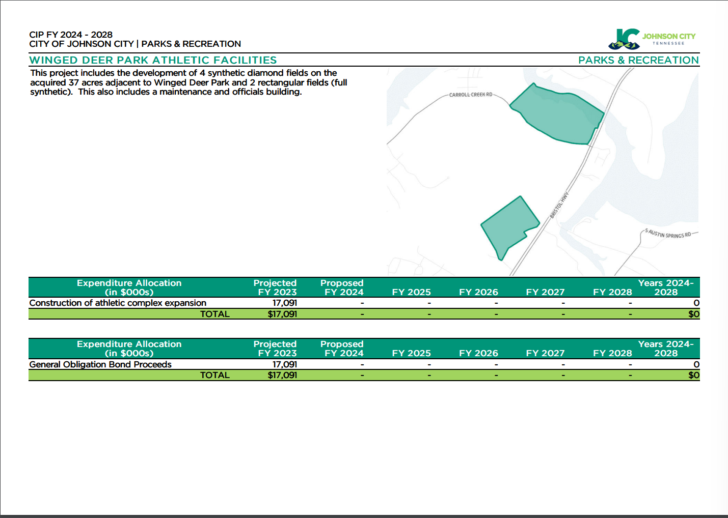
Source: https://cms7files.revize.com/johnsontn/document_center/Budget/cip_%202024-2028.pdf (JC CIP FY 2024-2028)

